Plenary Speech – Speaker Biography

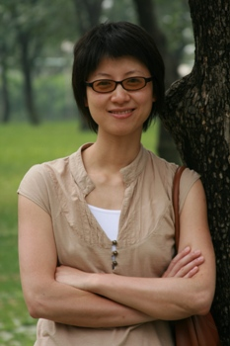
Looking Ahead
Presenter: Evelyn Zhang (China Program Director, Evergreen Education Foundation)
Evelyn Zhang is now working with Evergreen Education Foundation full-time as China Program Director since July 2008, overseeing and coordinating Evergreen programs in China.
Before joining Evergreen, Evelyn had worked in ShinShin Educational Foundation as satellite library program manager since 2006, on building primary school libraries as satellite libraries in Evergreen library network.
Prior to her NGO career, Evelyn has enjoyed a career in high-tech industry in both Silicon Valley, US and in China. She has 9 year experience serving companies in IT industry including Cisco, UTStarCom, IPInfusion, and 3PARData, in the fields of software development, system engineering, sales engineering, and software development management. She received a B.S. in Computer Science from Tsinghua University and holds an M.S. in Computer Science from Cornell University.

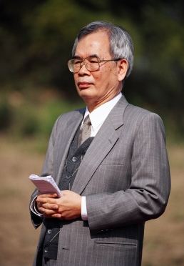
Plenary Speech
Best Practices I – Inspirations from both sides of the Taiwan Strait
- A Taiwan Rural Public Library – XinRong Memorial Library
Presenter: Ruizheng Gao (Founder, XinRong Memorial Library)
Mr. Ruizheng Gao is a lawyer who was born at ZhuShan, NanTou County. “No matter how long the tree shadow is at dusk, it is always connected with the root”, to Mr. Gao and his 5 brothers, Tagore’s poem led to the idea of building a library for their hometown. After two years’ construction and 120 million TWD spent, the XinRong Memorial Library which occupies 1500 Ping, was open to the public in Feb. 2006.
The library has an elegant outlook, generous layout, and comprehensive facilities. Outside the building there are also children’s playground, small outdoor theatre, beautifully scattered trees and bushes, lamps, chairs, fountains, sculptures, and green.
The annual budget of the XinRong Library is over 10 million TWD. The book purchase budget is 2.5 million TWD and ten times that of the local public library. Three years after its opening, the collection has reached 60 thousand books.
Moved by Mr. Gao’s passion, upon the library’s opening, it attracted more than 200 volunteers including retired principals, teachers, government managers, professionals, housewives. The library is independent in book purchase, software, and operation which is rare in rural public libraries and an innovative model in Taiwan library world.
People at ZhuShan deem the XinRong Memorial Library “Another big study room in the house”. Besides borrowing books and reading books at the library, children come to the library for study after school, waiting for parents to pick them up later; At weekends or holidays, preschool kids and their parents all come to the parent-child classroom of the library for story-telling. Both kids and parents can find movies to enjoy, or borrow books and CD/DVDs. The XinRong Memorial Library has become the pride of ZhuShan folks, and a blessed venue gathering common identity and good fortune.

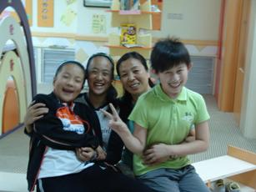
Plenary Speech
Best Practices I – Inspirations from both sides of the Taiwan Strait
- A Modern School Library – Beijing ZhongGuanCun No. 4 Elementary School Library
Presenter: Hong Lu (Director, ZhongGuanCun No. 4 Elementary School Library)
Hong Lu started her career as a librarian after she graduated from QuFu Normal University in 1990. In 2006 she received a Master degree from History Department in Capital Normal University, Beijing. With 15 years of experience in university library work, she came to ZhongGuanCun No. 4 Elementary School, Beijing in Sept. 2005 and became a Chinese Literature teacher and library director. Since then, she has been working hard with genuine care for the young readers, hoping every reader can savor the happiness of reading. Meanwhile, she is enjoying the wonderful sense of accomplishment as an elementary school librarian.
Her motto is – Infuse the book scent into a childhood.

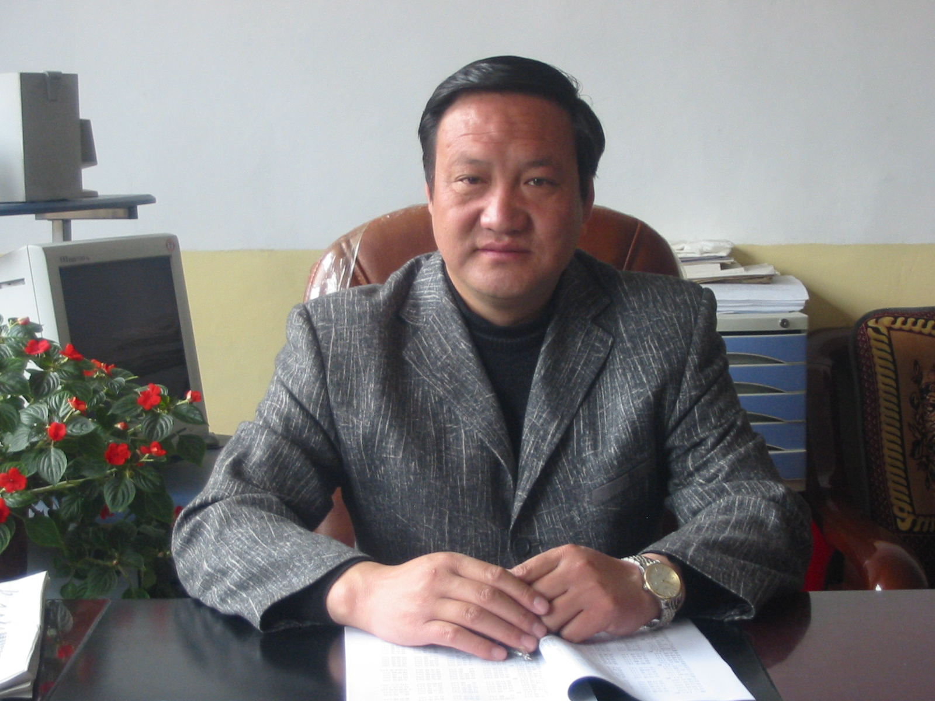
Plenary Speech
Best Practices II - Evergreen Footprints
- TianZhu, GanSu– Central and Satellite libraries
Evergreen Library Special Projects
- TianZhu, GanSu – Rural Information Service
Presenter: Guodong Jiang (TianZhu No. 1 High School Principal)
Guodong Jiang, from TianZhu County, GanSu Province, is a High School Senior Teacher. After graduating from TianZhu Normal School, he became a teacher in 1982. In 1992, he received a Bachelor degree on educational management from GanSu Educational Collage. Now he is the principal of TianZhu No. 1 High School.
He has been participated in Evergreen library program since 2001, leading the library development of TianZhu No. 1 High School, including community service projects. Currently he is designing and implementing TianZhu Rural Information Center project.

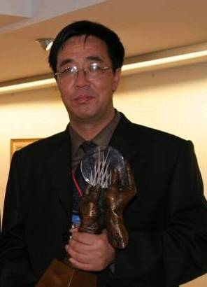
Plenary Speech
Best Practices II - Evergreen Footprints
- TongWei, GanSu– Agricultural Projects
Presenter: Tuowen Niu (TongWei No. 1 High School Dean)
Tuowen Niu is a High School Senior Teacher. He was Tongwei Educational Bureau Vice Director, Tongwei Vocational School Principal, Tongwei No.1 High School principal. Currently he is Tongwei No. 1 High School Dean.
From 1995 to 2000, Tuowen Niu was responsible for the implementation of both the Basic Education Project sponsored by the United Nations Children Foundation, and the UNDP401 project. Since 2001, he has been responsible for leading the Evergreen library development in Tongwei No. 1 High School, and actively involved in the exploration and execution of Evergreen rural library projects.

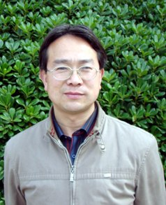
Plenary Speech
Best Practices II - Evergreen Footprints
- DanFeng, ShaanXi– Farmers’ Book Station
Presenter: Yonghong Lei (DanFeng High School Dean)
Yonghong Lei, after graduating from Educational Technology Department, ShaanXi Normal University, worked in Qinghai Oilfield Experiment High School. Since 2002 Yonghong Lei has been working in Danfeng High School, ShaanXi Province, in IT teaching and school management. He is familiar with technologies and methodologies of educational information dissemination. Since 2003 he has been actively leading various Evergreen projects in Danfeng High School.

Plenary Speech
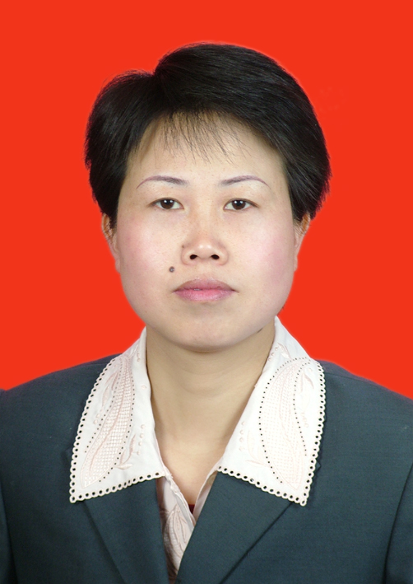
Best Practices II – Evergreen Footprints
- ZhenYuan, GuiZhou – Building a School Library for the Community
Presenter: Mei Long (Wende High School Vice Principal)
Mei Long graduated from History Department, GuiZhou Minority College. Since 1992, she worked in a variety of schools including ZhenYuan QingXi High School, ZhenYuan No. 1 School, ZhenYuan High School, HaiLiang Private High School in the city of ZhuJi, ZheJiang Province, and ZhenYuan WenDe High School. She has rich educational experience and her history teaching has won the first prize in QianDongNan Prefecture, and the 2nd prize in GuiZhou Province. She is High School Senior teacher, ZhenYuan lead history teacher, and now WenDe High School Vice Principal. In 2008 she joined Tao XingZhi Research Society in GuiZhou Province, hoping to devote herself to practice the rural education ideas of Mr. Tao XingZhi.


Break-out Session
Library Management I, II,
Library Assessment
Presenter: Jo B. Whitlatch (Professor, Library and Information Science, San Jose State University)
Jo Bell Whitlatch has a Ph.D. in Library and Information Studies, University of California, Berkeley. Her research interests and areas of special competence are: information seeking needs and behavior, user studies in libraries, evaluation of service organizations, and management of libraries. Publications include two books, The Role of the Academic Reference Librarian (1990), Evaluating Reference Services (2000), and articles in RQ, College & Research Libraries, Journal of Academic Librarianship, and the Reference Librarian. She has taught management and reference courses in the School of Library & Information Science, San José State University, 1987-2009, and until retirement in 2006, served as Associate Library Dean, San José State University (2001-2006) and History Liaison, San José State University (1992-2004).


Plenary Session
Best Practices III – Inspirations from the United States of America
Presenter: Madge H. Klais (Professor, School of Library and Information Studies, University of Wisconsin-Madison)
As an assistant professor in the School of Library and Information Studies at the University of Wisconsin-Madison, Madge Klais teaches courses in school library management, information literacy pedagogy, literature for children and young adults, and the history of books and print culture. Prior to her work at the university, she served as a classroom teacher, school librarian, program support teacher, and district-level director of the school library program in the Madison, Wisconsin, school district. Prof. Klais earned her Ph.D. in medieval history at the University of Wisconsin-Madison and conducts research on school librarians as instructional leaders and the history of children’s print culture.

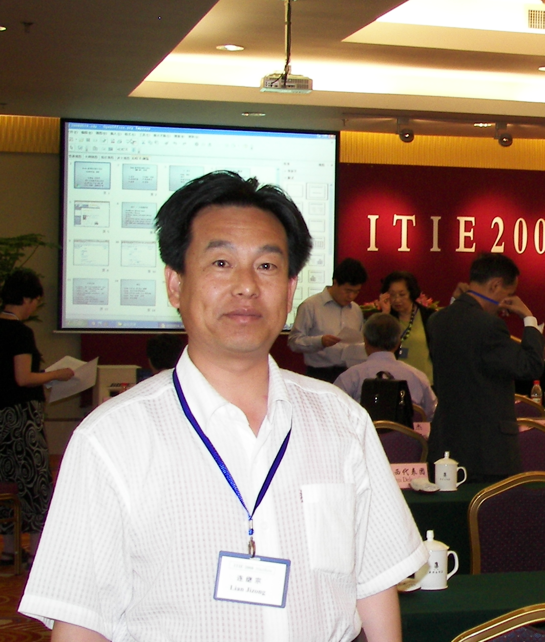
Plenary Session
Evergreen Library Special Projects
- TongWei, GanSu – Healthcare Education
Presenter: Jizong Lian (Tongwei No. 1 High School Vice Principal)
Jizong Lian, from HuiNing, Gansu, graduated from Mathematics department, GanSu Education College. He is currently Tongwei No. 1 High School Vice Principal, and High School Special-grade Teacher. He has won many rewards and titles including GanSu Young Teaching Expert, DingXi City Mathematics Education Leader, TongWei County Education Leader, DingXi District Excellent Teacher, etc. He has published 13 papers in journals such as GanSu Education, Maths Teaching Research, Teaching and Management, DingXi Education, etc. Since 2001 he has been involved in the Evergreen Library project design and implementation at TongWei No. 1 High School.

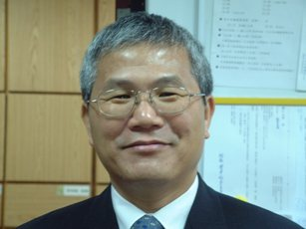
Break-out Session
Sharing Library Experience
1) Comparative Study of the Public Library Service Guidelines between China, Taiwan and IFLA
Presenter: Qingzhen Mao (Professor, Library and Information Science, Fu-Jen University, Taiwan)
Qingzhen Mao graduated from the Department of Library Science, Fu-Jen University in 1976. After protecting his homeland for two years, he worked in Taiwan Normal University Library for a while, wandered about for some time, then studied in the Department of Library and Information Studies, Queens' University of Belfast, United Kingdom for one year and received Librarian Certificate. In 1982 he worked in ZhongShan University Library, and received a Master degree from Library Science Department, Taiwan University. From 1984 till this date, he has worked in the Department of Library and Information Science, Fu-Jen University.
Besides teaching and research, Prof. Mao is dedicated to community service. After 921 Earthquake in 1992, he founded the Library Service Team of the Department of Library and Information Science, Fu-Jen University and became the guiding teacher of the team. Since Jan. 2001, this team has served 62 schools and organizations in XinZhu, NanTou, TaiZhong, HuaLian, MiaoLi, TaiNan. In Feb. 2009, the team came to Mainland China for volunteering service the first time. Prof. Mao hopes that through the team and the service, students in the library-related fields can inherit the spirit of caring for the society, reach consensus, form a special tradition, re-demonstrate the intention of founding a library by the our forefathers, and advocate the library’s fundamental role of reducing the information gap.
Meanwhile, Prof. Mao has been promoting free software for years. He believes the free software provides one feasible way to reduce the information gap, and promote the information literacy of the underserved in this information age.


Break-out Session
Sharing Library Experience
2) Library Security and Openness
Presenter: Shupin Chiu (Instructor, Central Police University, Taiwan)
Shupin Chiu received a Ph.D. on criminology from Taiwan Central Police University, a M.S. on Library and Information Science from Tamkang University.. She is now an instructor in Taiwan Central Police University and Taipei Police College. In the past decade, she has published about 30 papers and her research interest is on library and criminology, and library security. She has published < Tourism Security: Tourist Crime and Prevention>, <Library and Information Management: Criminal Justice Reference Information" <Library Security: Book Theft and Tear Off Research> and her book <Tourism Security – Tourism crimes and prevention> is about to be published by Beijing Tourism Education Publisher. Besides research and teaching, she loves travelling, and has volunteered in mainland China, Belize, Panama. Her personal website http://hk.geocities.com/chiushupin/

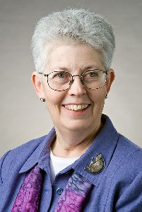
Break-out Session
Sharing Library Experience
- Serving Minority Communities
Presenter: Louise S. Robbins (Professor and Director, School of Library and Information Studies, University of Wisconsin-Madison)
Louise Robbins will retire in August from her position as Professor and Director, School of Library and Information Studies, University of Wisconsin-Madison. Her historical research has won numerous awards. She has been named both Wisconsin Librarian of the Year (2001) and an Oklahoma Library Legend (2007). She has taught courses in the foundations of library service; management of libraries and information agencies; libraries in the global knowledge society; and tribal, libraries, archives and museums; and intellectual freedom. Robbins has lectured widely in the United States and abroad. She has been active in university governance and in the Association for Library and Information Science Education, including a two-year stint as president. She and her husband, Robby, have two children and two grandchildren.

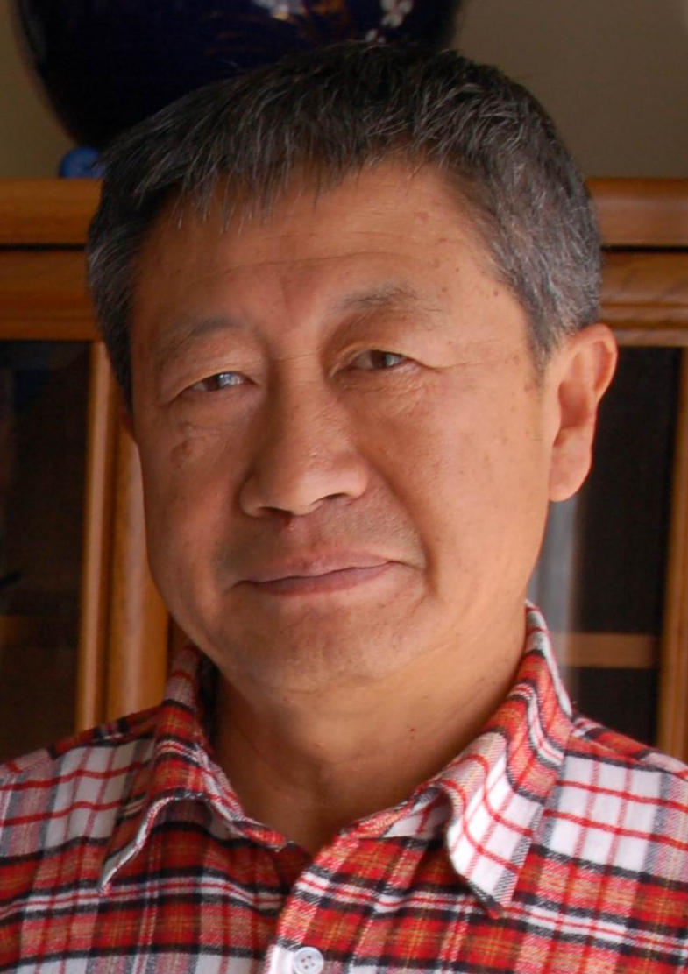
Panel Discussion
Theme: Libraries Serving Rural Communities
Panelist: ZhaoXiang Hui (CERLS YunNan Representative)
ZhaoXiang Hui is an expert in weed prevention and removal, and Vice Chairman of the Weed Science Group, the China Society of Plant Protection. After graduating from Crop Cultivation Field, KunMing Agriculture and Forestry College (now KunMing University), he has worked on the experimentation, demonstration, and promotion of agricultural technology for a long time. He made prominent contributions to weed prevention and removal, and has received many awards including special allowance by China’s State Council, and YunNan model worker. During 40+ years of his career, he started in grass-roots, and went from technician, agronomist, the head of different levels of agricultural technology unit, to the head of agriculture bureau, thus having rich experience in agricultural technology and administration/management. He is also active in social cause and community service. He has been KunMing 7th, 8th, 9th NPC (National People’s Congress) member and YunNan 7th, 8th, 9th People's Political Consultative Conference member. He is now KunMing Government Staff, and Technology Advisory Panel Member. Familiar with rural China, farmer, and agriculture, he has experienced the Great Leap Forward, the People's commune, and the drastic changes of the countryside since the third Plenum of the 11th Communist Party of China Central Committee. He is willing to devote himself to the reform and development of the rural Chin

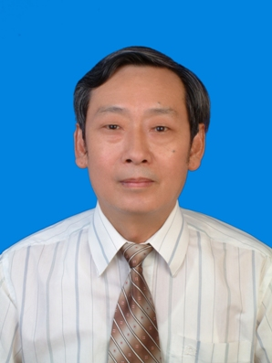
Panel Discussion
Theme: Libraries Serving Rural Communities
Panelist: Pingnan Shao (CERLS GuiZhou Representative)
Pingnan Shao is Senior Agronomist and graduated from the Department of Agronomy, GuiZhou Agricultural College.
From 1970 to 1982, he worked in SiNan County and ShiQian County, researching and promoting wheat and rape cultivation technologies, the technology of double-crop rice, hybrid rice seed production and cultivation demo, etc. In 1982, he transferred to ZhenYuan County, promoting agricultural technologies, and organizing agricultural zoning, detailed survey of land. He has received 20+ awards on technology accomplishment from the district, 5 awards from GuiZhou Province, and has published 30+ papers among which 10+ have been published on province-level journals. In 1992, he was selected by County Council into the book <The Heroes of China Reform>. In 1993, he was elected as the Deputy Chief of ZhenYuan County. In 1996, he was elected the Vice Chairman of the People's Political Consultative Conference, the QianDongNan Prefecture, and worked hard for the economic development and social improvements of ZhenYuan County and the QianDongNan Prefecture. In 2002, he compiled all the papers and articles he wrote during the past 30 years into a book - <The Traces of Time> with more than 240,000 words. He is currently GuiZhou Representative for China Evergreen Rural Library Service Center, and Southern Advisor for Zigen Foundation.

