Small Project Presenter Biography

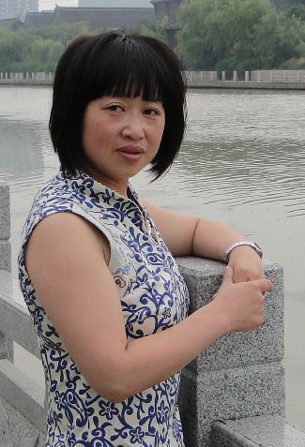
Ping Bu, HuaiAn No. 1 High School, JiangSu
I Have A Date with Classics
Ping Bu graduated from the Department of Chinese Language and Literature, SuZhou Railway Normal University. She has 10 years of teaching experience, practicing theory, sharpening her skills, and reflecting. As a result, she has published papers in City-level and State-level journals, including <Re-understand the Leading Position of Teachers in the Teaching of Reading>, <The Pleasure of Close Communication with the Students>, <Writing from Life is Pleasant Writing>, <Stimulate the Students’ Interest in Writing and Improve their Capability of Writing>. Her students won City-level First Prize in JiangSu “Students and Society”essay contest. In 2008, she was selected as a participant of the HuaiAn “Ten-Hundred-Thousand”talent nurturing program.

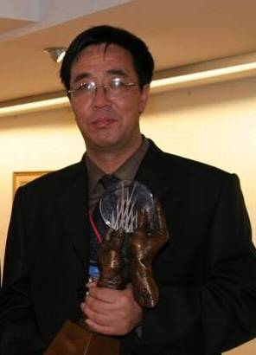
Tuowen Niu, TongWei No. 1 High School, GanSu
One Man Newspaper
Tuowen Niu is a High School Senior Teacher. He was Tongwei Educational Bureau Vice Director, Tongwei Vocational School Principal, Tongwei No.1 High School principal. Currently he is Tongwei No. 1 High School Dean.
From 1995 to 2000, Tuowen Niu was responsible for the implementation of both the Basic Education Project sponsored by the United Nations Children Foundation, and the UNDP401 project. Since 2001, he has been responsible for leading the Evergreen library development in Tongwei No. 1 High School, and actively involved in the exploration and execution of Evergreen rural library projects.

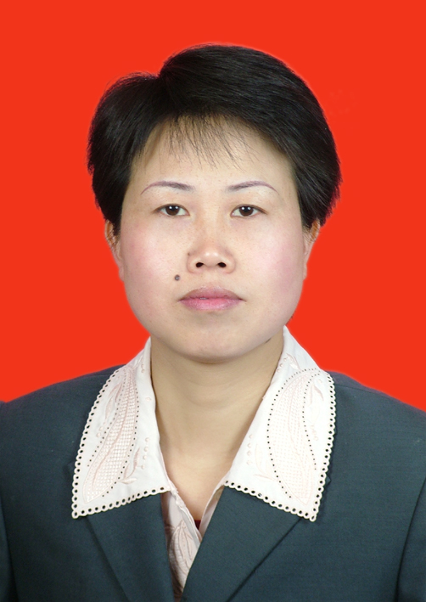
Mei Long, WenDe High School, GuiZhou
ZhenYuan Local History School-based Curriculum
Mei Long graduated from History Department, GuiZhou Minority College. Since 1992, she worked in a variety of schools including ZhenYuan QingXi High School, ZhenYuan No. 1 School, ZhenYuan High School, HaiLiang Private High School in the city of ZhuJi, ZheJiang Province, and ZhenYuan WenDe High School. She has rich educational experience and her history teaching has won the first prize in QianDongNan Prefecture, and the 2nd prize in GuiZhou Province. She is High School Senior teacher, ZhenYuan lead history teacher, and now WenDe High School Vice Principal. In 2008 she joined Tao XingZhi Research Society in GuiZhou Province, hoping to devote herself to practice the rural education ideas of Mr. Tao XingZhi.

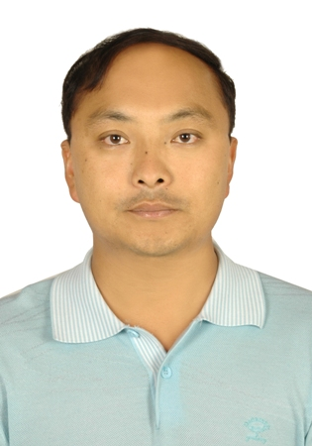
Qipeng Zhang, ShiDian No. 2 High School, YunNan
I Am A Little Editor-in-Chief
Qipeng Zhang, High School First-grade Teacher, graduated from the Department of Chinese Language and Literature, YunNan Normal University in 1997. Since 1997 he has been teaching Chinese in ShiDian No. 2 High School. He has been class advisor for 10 years, taught 12th grade 5 times, and has prominent achievements. In 2005 he became Vice Principal, in charge of teaching management, and school library. In 2009 he was selected as Excellent Teacher in YunNan.

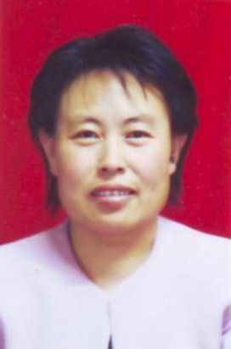

Xiaorong Zhang, Tongwei Public Library
Community Forum “Tongwei People”
Xiaorong Zhang received a college degree. Since 1996 she has been working in Tongwei Public Library as Vice Director, in charge of library services. She has worked in circulation and cataloguing. Her research paper has won Excellent Award in the seminar held by GanSu Society of Library.

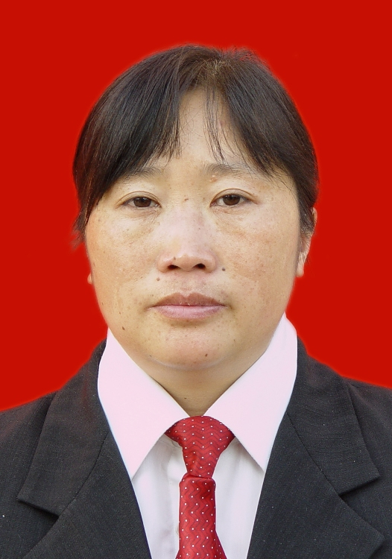
Guohui Zhao, WenDe High School, GuiZhou
Peach Flower Jellyfish in WuYang River, ZhenYuan
Guohui Zhao graduated from the Department of Biology Technology, Qiandongnan Normal College in 1993. She came to teach at YangPing High School, ZhenYuan County. She attended Prefecture-level lead teacher training, gave biology demo class. Her paper received 2nd prize in the Biology Teaching Paper Contest. Since 2005 she has been teaching at WenDe High School. Feeling the urge to expand her knowledge to better serve her teaching, she is now studying in the Department of Biology Science, GuiZhou Normal University.

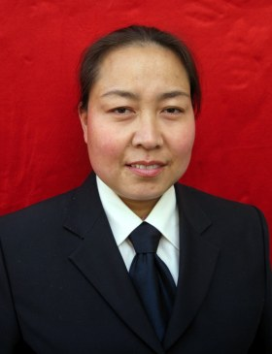

Shanshan Wang, DanFeng High School, ShaanXi
Grow Up in Reading
Shanshan Wang is from DanFeng County, ,ShaanXi Province. She received a Bachelor degree in 1988, and is currently High School 1st-grade Teacher. From 1988 to 2005 she worked as a teacher. Since 2005 she started her career as a librarian in DanFeng School Library. Her strong sense of responsibility and creativity in work have won her wide praise from teachers and students alike.

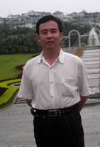

Changnian Yang, TianZhu No. 1 High School, GanSu
Rotational Book Corner to Improve Reading through Expansion and Comparison
Changnian Yang, High School 1st-grade Teacher, received a Bachelor degree in Chinese Language and Literature, became a teacher since 1985. He is currently a Chinese teacher in TianZhu No. 1 High School. His paper <Negative Impacts of Information Technology on Ethics> won 2nd prize in ITIE2006. He is currently a member of the Oral History Group in the TianZhu Rural Information Center project.

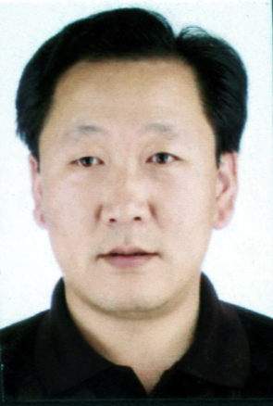
Xiangqi He, TongWei No. 1 High School, GanSu
Little Mathematician
Xiangqi He graduated from the Department of Mathematics, ZhangYe Normal College. He received a Bachelor degree from the Department of Mathematics and Applied Mathematics, TianShui Normal University. Since 1991 he has been teaching mathematics at TongWei No. 1 High School. He is High School 1st-grade Teacher, currently the leader of the Mathematics Teaching and Researching group. In Oct. 2007, his teaching has won the 1st prize in GanSu High School Mathematics Classroom Teaching Contest. In Nov. 2008, his teacing has won the 2nd prize in the 4th CASIO National High School Young Teacher Class Demo and Contest. He has also published many papers on journals such as <High School Subjects of Science>. His students have won 1st and 2nd prizes in National Mathematics Contest.

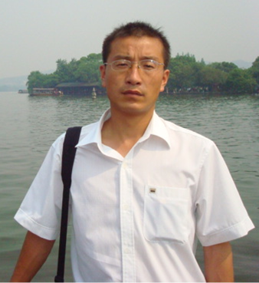
Jianlu Li, LiJiaShan High School, QingHai
Reading Program
Jianlu Li graduated from QingHai Normal College in 1998. Since then he has been teaching at LiJiaShan High School for 11 years. Since 2006 he has been involved in the development of Evergreen school library, collecting and organizing data and materials accumulated in the library programs.

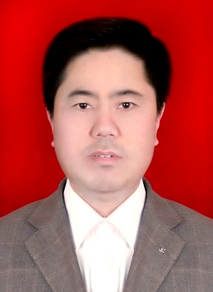
Facang Zhang, HuiNing No. 4 High School, GanSu
Developing Healthy Reading Habits
Facang Zhang, High School Senior Teacher, Mathematics Teacher, currently HuiNing No.4 High School Vice Principal and Dean. He graduated from QingYang Normal College in 1981, and studied in the Department of Mathematics of Northwest Normal University from 1991-1994. Since 1981, he has worked in HuiNing No. 1 High School, HuiNing High School, and HuiNing No. 4 High School, playing teaching and management roles. In 2000 he was awarded HuiNing Lead Teacher, elected as director of the BaiYin City Society of Mathematics, and selected as judge of BaiYin City and HuiNing County Excellent Classroom Teaching Contest many times. He has written 20+ papers, and his students have won 2nd prize in national contests. In 2004, his project in the National 10th Five-year Plan “How to cultivate innovation capability of students” has passed appraisal and won first prize.

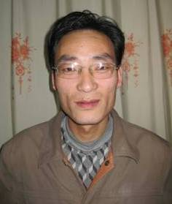

JingXian Chang, MaYing Middle School, GanSu
Crop and Vegetable Cultivation Technology Brochure
Jingxian Chang, High School 1st-grade Teacher with Bachelor degree. He taught biology at LiDian Middle School, TongWei between 1998 to 2007. Since Sept. 2007, he has been a biology teacher and the leader of the Biology and Chemistry Teaching and Researching Group at MaYing Middle School, TongWei County.

